**Unity API (UI Button, SceneManager, PlayerPrefs, Static Classes)**

**LAB # 8**



**Fall 2024**

**CSE-411L Intro to Game Development Lab**

Submitted by: **Ali Asghar**

Registration No.: **21PWCSE2059**

Class Section: **A**

“On my honor, as student of University of Engineering and Technology, I have neither given nor received unauthorized assistance on this academic work.”

Submitted to:

**Engr. Abdullah Hamid**

Date:

**25th December 2024**

**Department of Computer Systems Engineering**

**University of Engineering and Technology, Peshawar**

**Objective:**

In this lab we further explored the Unity API.

**Tasks:**

1. Open or create a Unity scene.
2. Create a simple UI with a Play button. When pressed, the current scene should close, and a new scene (the game from the previous lab) should open.
3. In the previous lab’s scene, add a new text box to the UI to display the high score.
4. For score management, create a new class called ScoreManager.cs. In this class:
   1. Define a static integer for the score.
   2. Add non-static references for highScore and score.
   3. Ensure this class manages both the score and the high score.
5. Include a static void function in the ScoreManager.cs class to be called when the game is over. This function should handle high score logic, updating the high score if the current score is higher.
6. In the game scene (from the previous lab), the Game Over panel should include
   1. two additional buttons:
   2. Exit: Returns to the scene with the Pl

**Code:**

**MainManager class**

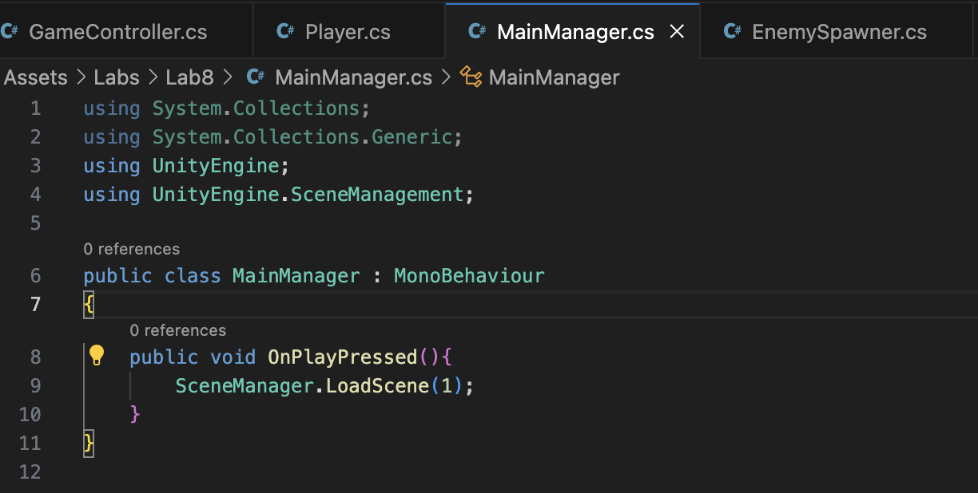

**ScoreManager class**

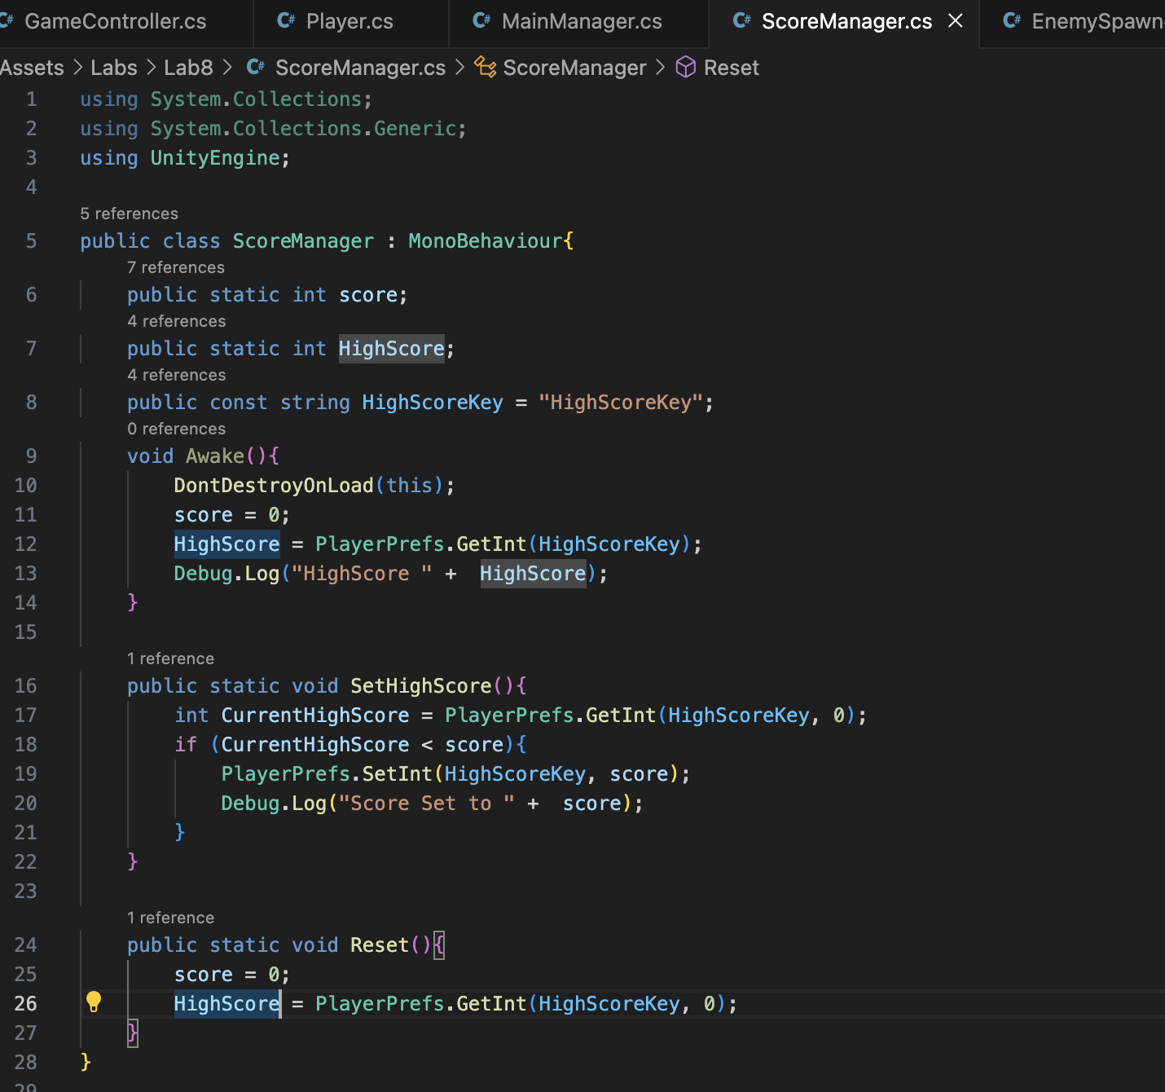

**GameController class**

This script is the same as lab 7

**Output:**

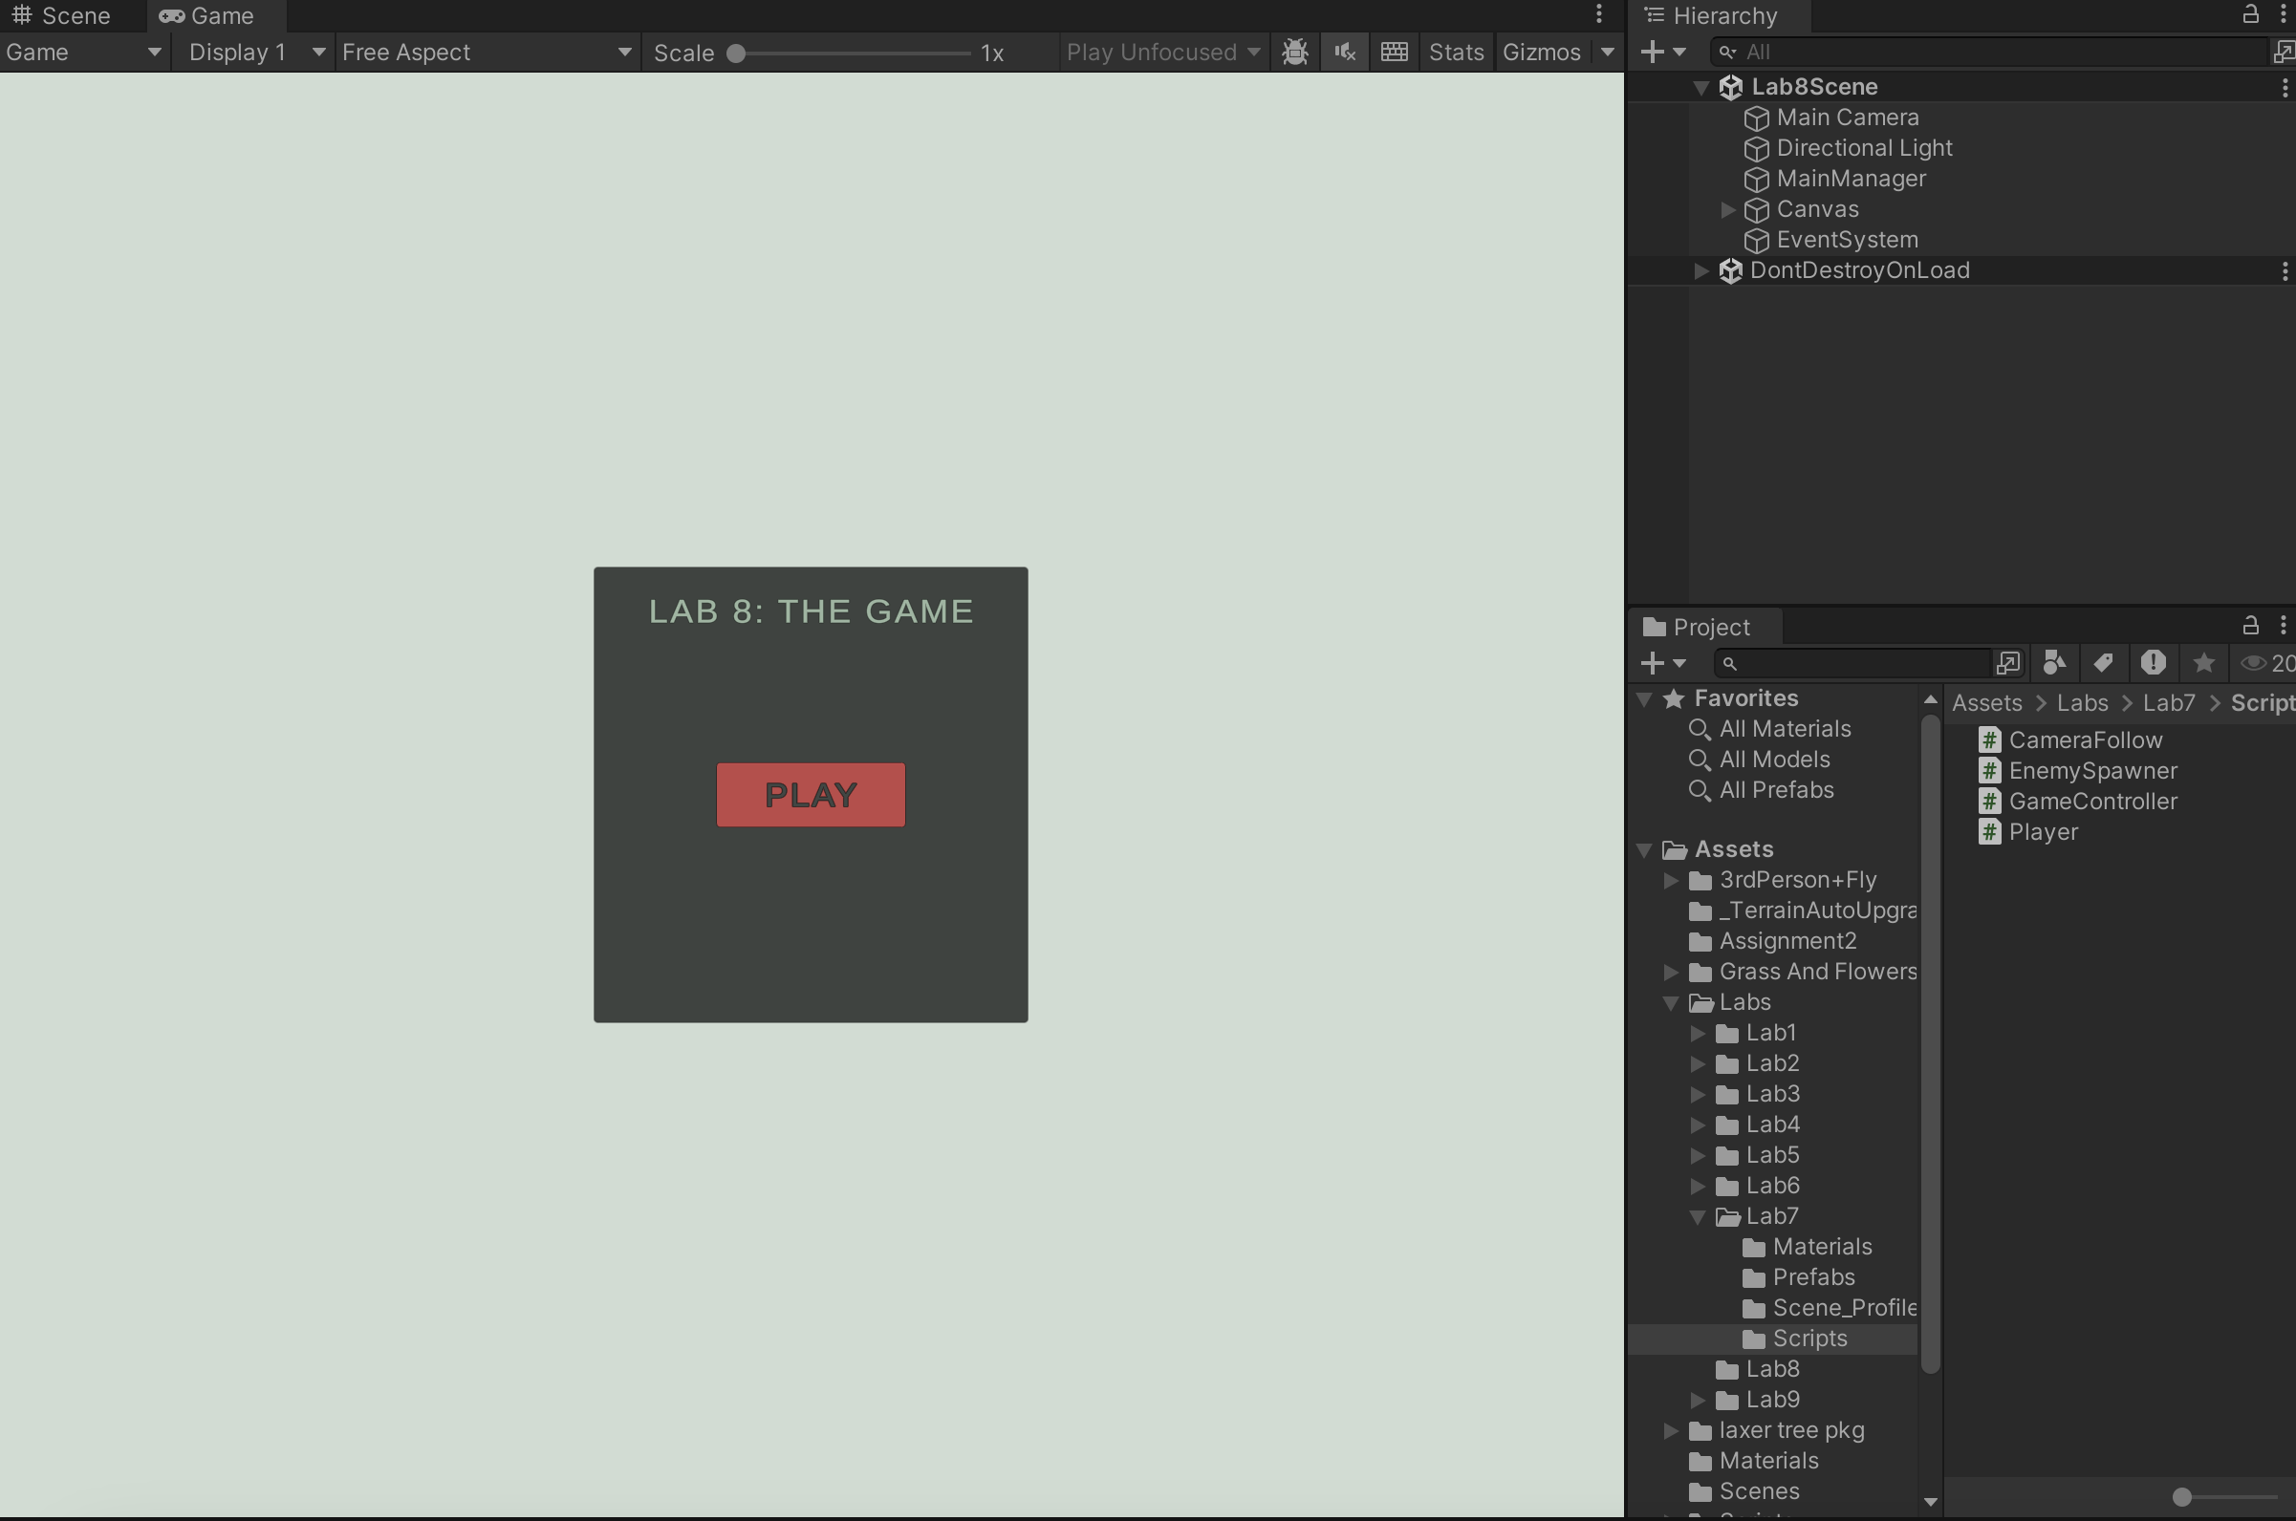

The Gameplay scene is the same as lab 7